BANKING WEBSITE

OUTPUT –

CODE –

Index.html (LOGIN PAGE)

<!DOCTYPE html>

<html lang="en">

<head>

    <meta charset="UTF-8">

    <meta name="viewport" content="width=device-width, initial-scale=1.0">

    <link rel="stylesheet" href="styles.css">

    <title>Banking Website</title>

</head>

<body>

    <div class="container">

        <h1>HDFC Bank Login </h1>

        <div id="loginForm" class="border-box">

            <label for="username">Username:</label>

            <input type="text" id="username" name="username">

            <label for="password">Password:</label>

            <input type="password" id="password" name="password">

            <a href="dashboard.html">Login</a>

        </div>

    </div>

</body>

</html>

OUTPUT – (Dashboard)

CODE –

Index.html (Dashboard Page)

<!DOCTYPE html>

<html lang="en">

<head>

    <meta charset="UTF-8">

    <meta name="viewport" content="width=device-width, initial-scale=1.0">

    <link rel="stylesheet" href="styles.css">

    <title>Banking Dashboard</title>

</head>

<body>

    <div class="container">

        <h2>Dashboard</h2>

        <ul>

            <li><a href="account-overview.html">Account Overview</a></li>

            <li><a href="profile.html">Profile</a></li>

            <li><a href="transaction-history.html">Transaction History</a></li>

            <li><a href="faq.html">FAQ</a></li>

        </ul>

    </div>

</body>

</html>

OUTPUT – (Account Overview)

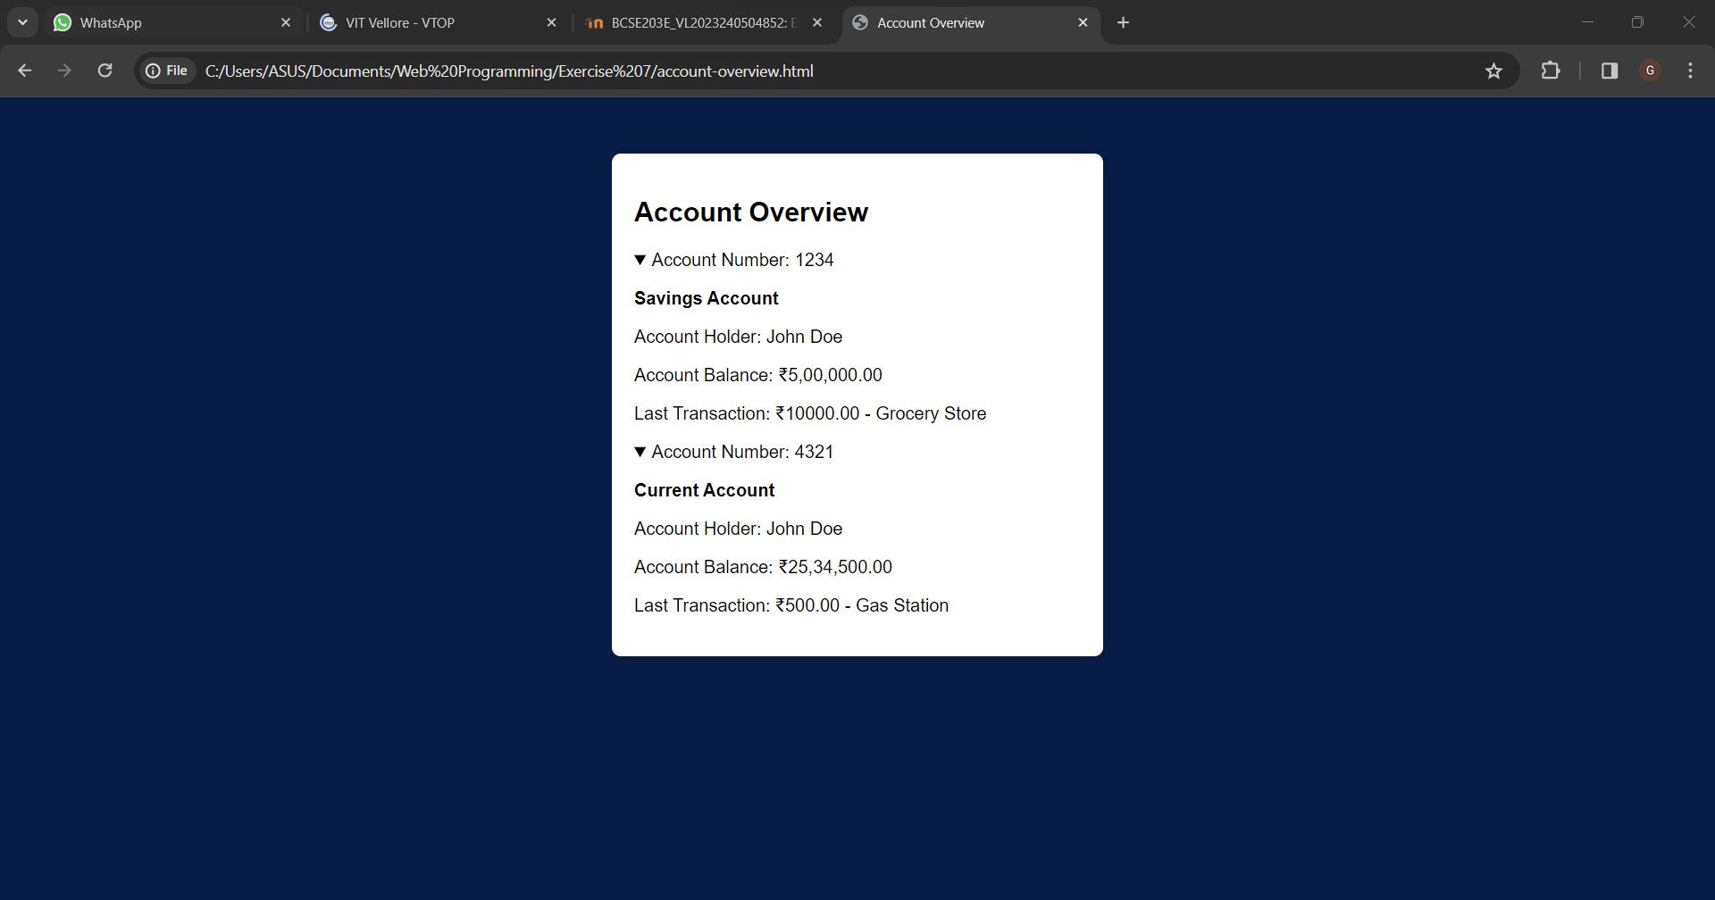

CODE –

Index.html (Account-Overview Page)

<!DOCTYPE html>

<html lang="en">

<head>

    <meta charset="UTF-8">

    <meta name="viewport" content="width=device-width, initial-scale=1.0">

    <link rel="stylesheet" href="styles.css">

    <title>Account Overview</title>

</head>

<body>

    <div class="container">

        <h2>Account Overview</h2>

        <details>

            <summary>Account Number: 1234</summary>

            <p><strong>Savings Account</strong></p>

            <p>Account Holder: John Doe</p>

            <p>Account Balance: ₹5,00,000.00</p>

            <p>Last Transaction: ₹10000.00 - Grocery Store</p>

        </details>

        <details>

            <summary>Account Number: 4321</summary>

            <p><strong>Current Account</strong></p>

            <p>Account Holder: John Doe</p>

            <p>Account Balance: ₹25,34,500.00</p>

            <p>Last Transaction: ₹500.00 - Gas Station</p>

        </details>

    </div>

</body>

</html>

OUTPUT – (Profile)

CODE –

Index.html (Profile Page)

<!DOCTYPE html>

<html lang="en">

<head>

    <meta charset="UTF-8">

    <meta name="viewport" content="width=device-width, initial-scale=1.0">

    <link rel="stylesheet" href="styles.css">

    <title>Profile</title>

</head>

<body>

    <div class="container">

        <h2>Profile</h2>

        <p><strong>Name:</strong> John Doe</p>

        <p><strong>Email:</strong> john.doe@example.com</p>

        <p><strong>Address:</strong> 123 Main Street, Cityville</p>

        <p><strong>Phone:</strong> +1 (555) 123-4567</p>

        <p><strong>Account Number:</strong> 1234567890</p>

        <p><strong>IFSC Code:</strong> HDFC012345</p>

        <p><strong>Branch:</strong> Vellore Branch</p>

        <p><strong>Account Type:</strong> Savings Account</p>

        <p><strong>Opening Date:</strong> January 1, 2022</p>

    </div>

</body>

</html>

OUTPUT – (Transaction History)

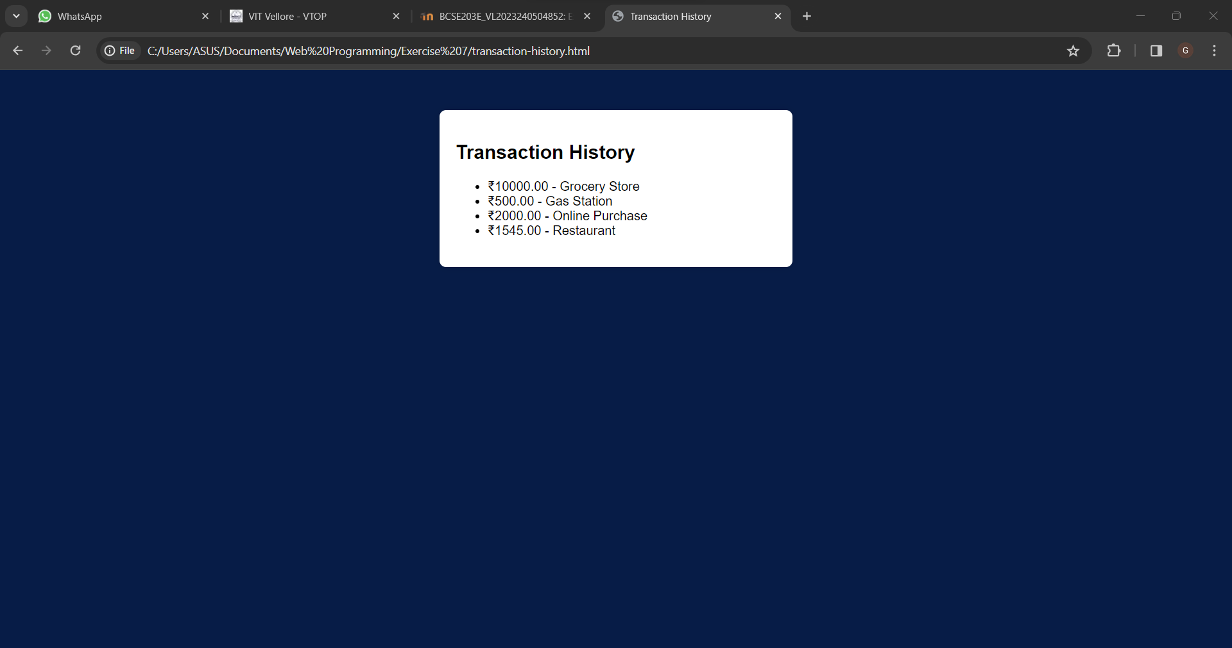

CODE –

Index.html (Transaction History Page)

<!DOCTYPE html>

<html lang="en">

<head>

    <meta charset="UTF-8">

    <meta name="viewport" content="width=device-width, initial-scale=1.0">

    <link rel="stylesheet" href="styles.css">

    <title>Transaction History</title>

</head>

<body>

    <div class="container">

        <h2>Transaction History</h2>

        <ul>

            <li>₹10000.00 - Grocery Store</li>

            <li>₹500.00 - Gas Station</li>

            <li>₹2000.00 - Online Purchase</li>

            <li>₹1545.00 - Restaurant</li>

        </ul>

    </div>

</body>

</html>

OUTPUT – (FAQ)

CODE –

Index.html (FAQ Page)

<!DOCTYPE html>

<html lang="en">

<head>

    <meta charset="UTF-8">

    <meta name="viewport" content="width=device-width, initial-scale=1.0">

    <link rel="stylesheet" href="styles.css">

    <title>FAQ</title>

</head>

<body>

    <div class="container">

        <h2>Frequently Asked Questions (FAQ)</h2>

        <h3>Q: How can I reset my password?</h3>

        <p>A: You can reset your password by visiting the "Forgot Password" page and following the instructions.</p>

        <h3>Q: How can I contact customer support?</h3>

        <p>A: You can reach our customer support team at support@examplebank.com or call us at +1 (555) 123-4567.</p>

        <!-- Add more FAQ items as needed -->

    </div>

</body>

</html>